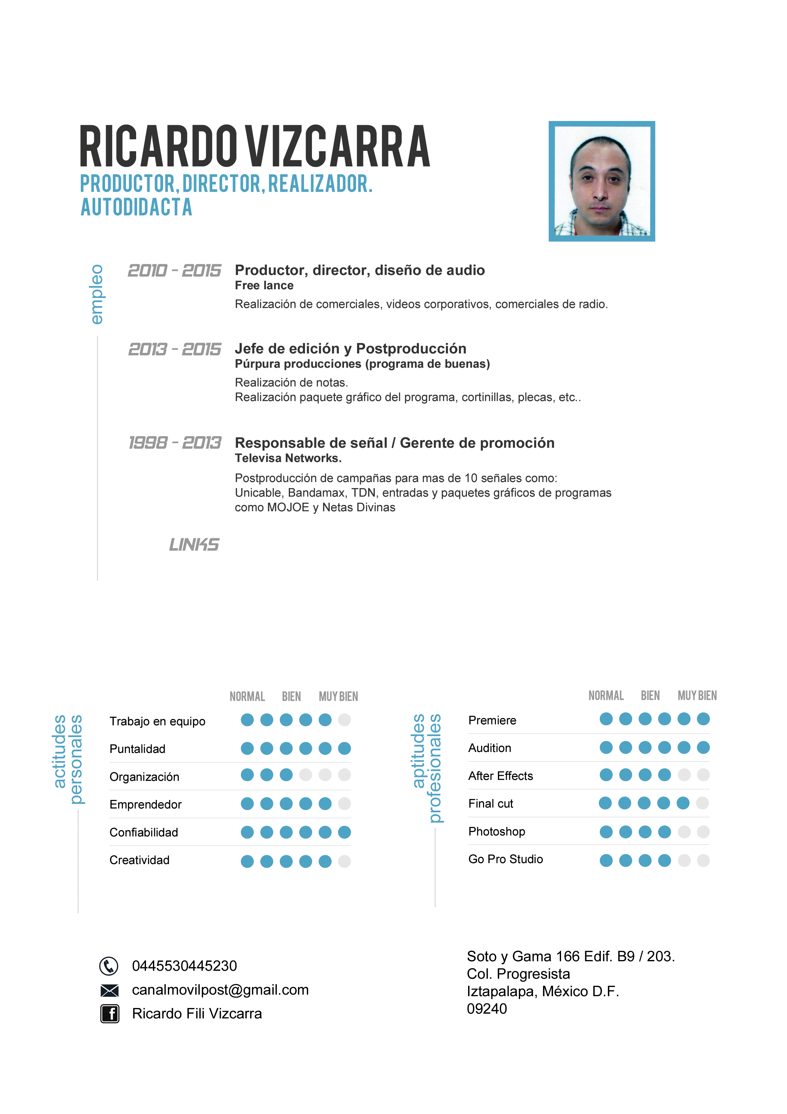

Corporativo….. <https://www.youtube.com/watch?v=zJ1UdTWVR-c>

Aviación Mex... <https://www.youtube.com/watch?v=55EXo8SvlC4>

Mazahuas…… <https://www.youtube.com/watch?v=kRwQtIa57nY>

Deportes…..….<https://www.youtube.com/watch?v=TjXxtMyz_Ps>

Comercial.……<https://youtu.be/QmHLXV2xOao>

Sindicato……. <https://www.youtube.com/watch?v=Z6divSoDMpc>

Turismo ….…. <https://www.youtube.com/watch?v=OccI27s7lh4>