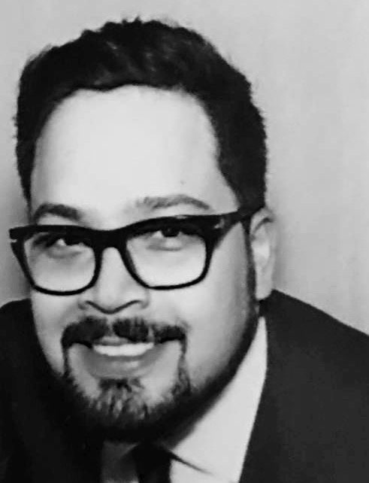**José Luis Arroyo Velázquez**

[**jlarroyo@icloud.com**](mailto:jlarroyo@icloud.com)

**+52 1 55 4554 0725**

**Texas 105, Col. Nápoles,**

**CP 03810, Mexico City, Mex**

**PERSONAL STATEMENT**

During my career, I have been continuously looking for challenges that advance my problem-solving skills. I have gathered great experience in Content Creation and Media Processing. I am interested in continuing my professional growth and knowledge in Content Management and Distribution.

WORK EXPERIENCE

Media Processing Manager - Clarovideo - Current Employment

America Móvil Content Media - www.clarovideo.com

Mexico City

##### Responsibilities

* Manage all media processing for Clarovideo.
  + Quality Control
  + Standardization
  + Audio Conformance
  + Subtitling
  + File conversions.
* Manage a team of 14 Video Technicians and Video Editors.
* Asses all incoming media from new Content suppliers (Onboarding).
* Consult on Original Content Postproduction workflows.

Postproduction Manager – November 2011 - February 2016

Labodigital - [www.labodigital.mx](http://www.labodigital.mx)

Mexico City

##### Responsibilities

* Create and supervise Digital intermediate Workflows for Feature Films and TV Series
  + Color Management (DCI, Broadcast)
  + VFX Pipeline
  + Motion Graphics
  + Mastering
  + Deliverables (DCI, File, Tape)
* Evaluate Bids before sending out to clients.
* Vet freelance artists (Compositors, Colorists, Online Editors)
* Communication with third party Vendors.
* Account Management (Budget supervision)
* Projects include:
  + The Secret Life of Walter Mitty (20th Century Fox)
    - Graphic Elements localization for LATAM Territory,
  + Sr. Avila (HBO Latin America)
    - 4K Workflow (Dailies, Digital Intermediate, Mastering)
  + Dios Inc (HBO Latin America)
    - 4K Workflow (Dailies, Digital Intermediate, Mastering)
  + Captive (2015) (Paramount Pictures)
    - Digital Intermediate
    - Deliveries Supervision
  + Nosotros Los Nobles (Alazraki Films)
    - Dust busting, Digital Intermediate

Producer – January 2010 - October 2011

PRN - A Technicolor Company - <http://www.prn.com>

Mexico City

##### Responsibilities

* Create visual content with Copy provided by creative for Retail Channels
  + 2D & 3D Animation
  + Motion Graphics
  + Storyboarding and Layout
* Create Channel IDs
* Develop Channel Guidelines for each individual Retail Client.

Animator – January 2008 - October 2010

Ciberfilms - [www.ciberfilms.com](http://www.ciberfilms.com)

Mexico City

##### Responsibilities

* 3D Modeling (Autodesk Maya)
* Rigging (Autodesk Maya)
* Character Animation (Autodesk Maya)

**EDUCATION**

Advanced Design Visualization Postgraduate Diploma - August 2006 - June 2007.

Umeå Institute of Design (Umeå, Sweden)

* Studio Type Program
* Short Animation Graduation Project

BA Industrial Design - August 2001 - December 2005.

Instituto Tecnológico y de Estudios Superiores de Monterrey Campus Ciudad de México

* Part of Student Association
* Participant in Exchange Programs
  + Politecnico Di Torino (Turin, Italy)
  + Institute National des Sciences Apliques (Lyon, France)
  + Art Institute (Poznan, Poland)

**PERSONAL INTERESTS**

* **Film & TV**
* **Animation**
* **Tech Industry**
* **Computer Science**
* **Music Production**

**REFERENCES**

References are available on request.