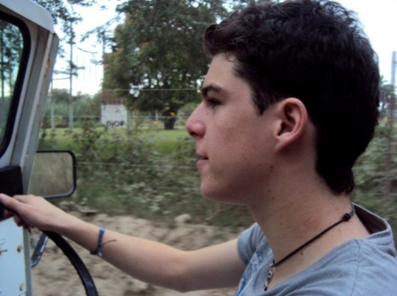
Fulvio Ricardo Prian Zama
CAPACIDADES

- Redacción formal e informal, argumentativa y persuasiva de alta calidad.
- Comunicación clara y nítida así en público como en privado.
- Manejo de programas de computo edición de texto (Office) y audio (Pro-Tools y Ableton)
- Interpretación y análisis con respecto a calidad artística de una obra.
- Buen manejo de tiempos y logística de planeación.
- Liderazgo e iniciativa, compromiso e interés.
- Instrumentos Complementarios: Guitarra (8 años).Harmónica, Ukulele,
IDIOMAS:
Inglés – 98% (First Certificate in English)
Francés – 40% (Delf A2)

55-25-77-32-89
56-65-09-73

fprianz33@gmail.com

Cda. Tenancalco #72 - D, Tlalpan, Cd. Mx
Participar en la creación y producción de proyectos que promuevan el arte y la cultura, fomentando al crecimiento de la empresa así como mi desarrollo profesional.

Educación:
Facultad de Filosofía y Letras UNAM - Letras Modernas Inglesas
Modern English Language Literature: Anglophone Literature of the 20th and 21st century.
Literatura Hispánica del siglo XX
Romantic literature: Mainly British and American poets and novelists; the Gothic and the Victorian Age.
Actualmente cursando el 3° semestre.
SAE Institute
Pro-Tools Avid Certification 101

Universidad de las Américas Puebla - Lic. Música (5 Semestres)

Español I & II
Razonamiento Cuantitativo.
Teoría Educativa.
Arte, Historia y Cultura.
Desarrollo de Formas y Estructuras Tonales I & II (Medioevo - Romanticismo)
Música del s. XX
Coro I & II – Activa participación de 1 año en Coro de Cámara UDLAP.
Piano (3 años)
Armonía Tonal I & II
Armonía Cromática I & II

Certificado de Perparatoria UNAM–CCH & Certificado de Bachillerato Internacional (IB

